**Meteor Maneuver – Will Smith**

Meteor Maneuver is a game in which the user will attempt to evade enemy obstacles. The game includes three difficulty levels, all of which contain unique differences. The user plays as a spaceship, capable of moving omnidirectionally. This ship can also shoot missiles, capable of destroying asteroids that can destroy the user’s ship. Destroying asteroids grants the user points, being added to the total ‘score’ component at the bottom of each action scene. Meteor Maneuver also includes multiple different scenes for the user to interact with: a help scene, which helps the user understand their goals, a hi-score scene, which shows the top 5 scores for each respective difficulty setting, a credit scene, which shows the creator of the application, as well as 3 different action scenes. Below is a rundown of the three action scenes, and their capabilities:

**Easy:** Easy mode attempts to familiarize the user with the game logic, and gameplay loop. They will encounter slow moving asteroids, encouraging the user to position themselves accordingly in order to destroy the asteroid and gain extra points.

**Medium:** Medium mode increases the overall difficulty of the game substantially. This level includes laser beams. Laser beams cannot be destroyed by missiles. The user will be forced to dodge the laser beams, whilst focusing on destroying asteroids. Furthermore, asteroids tend to move master in this difficulty setting. Watch out!

**Hard:** Hard mode should only be attempted by seasoned players. This mode also incorporates lasers and asteroids; however, they move much faster. On the difficulty selection screen, the user is not told what changes have been made to this difficulty- they are simply told “You Will Be Hacked”. This alludes to the game mechanic which starts at about 15 seconds into the run: the game window will begin to move around the screen, bouncing off the borders of the monitors as the user continues to play through the level. The user will have to maintain focus as the game window travels across the screen, dodging lasers whilst destroying asteroids, hoping to get a high score.

The hi-score system separates each difficulty level into their own prospective groups: each difficulty level will maintain their own hi-score sheet, allowing players to compete at their own desired level.

**Class Diagram:**

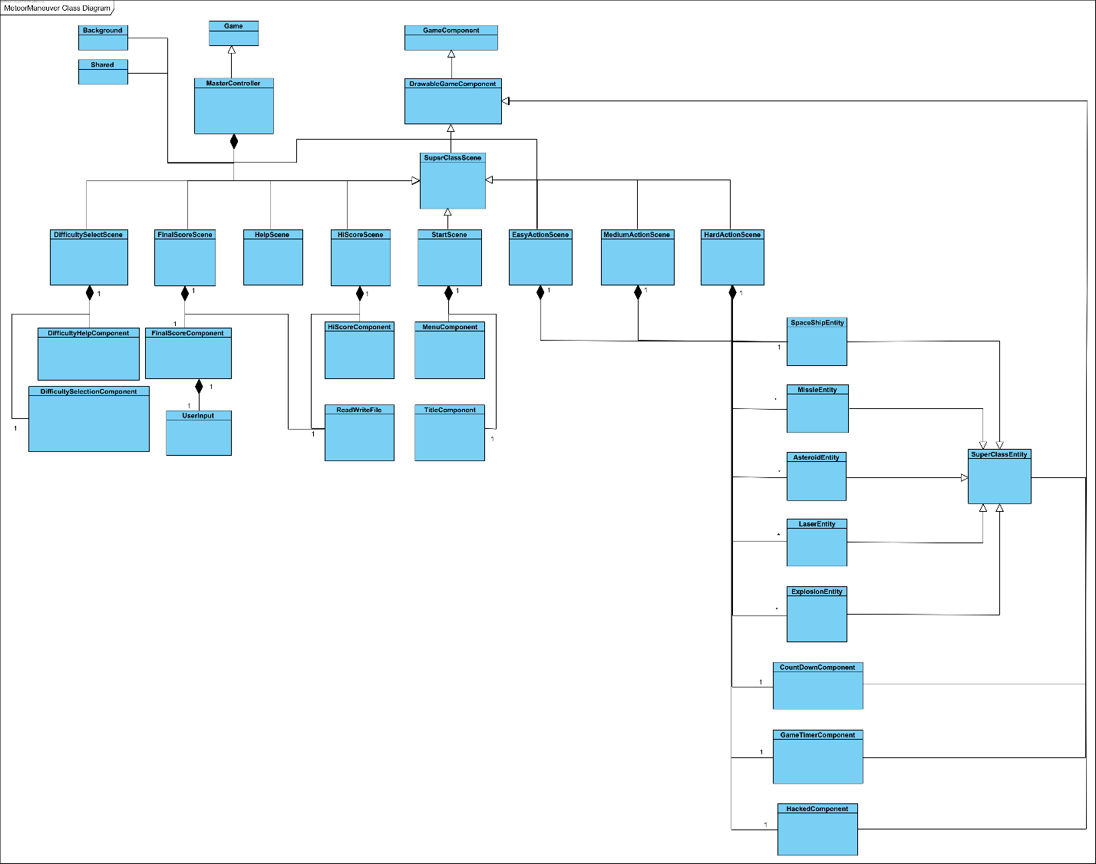

**References:**

Sound Effects: <https://freesound.org/>

Nite Flights – From Her To Infinity: <https://www.youtube.com/watch?v=DcDO7QOux8Y>

WaveShaper – Hearts: <https://www.youtube.com/watch?v=j3s6d4-KsNY>

Ship/Asteroid SpriteSheets: Will Smith © 2023

Laser SpriteSheet: <https://www.halfbrick.com/>

Explosion SpriteSheet: <https://toppng.com/free-image/explosion-sprite-png-2d-explosion-sprite-sheet-PNG-free-PNG-Images_163425>